Check Register & Balancing your Bank Account

Terms:

* Check Register -
* Bank Statement –
* **bank reconciliation**
* **Outstanding transactions:**

**Checking Register Codes often used:**

* + - **1001 = check payment – check number**
    - **DC =**
    - **ETF or ON –**
    - **ATM or WD =**
    - **DEP =**
    - **SC –**
    - **NSF -**

Check Register

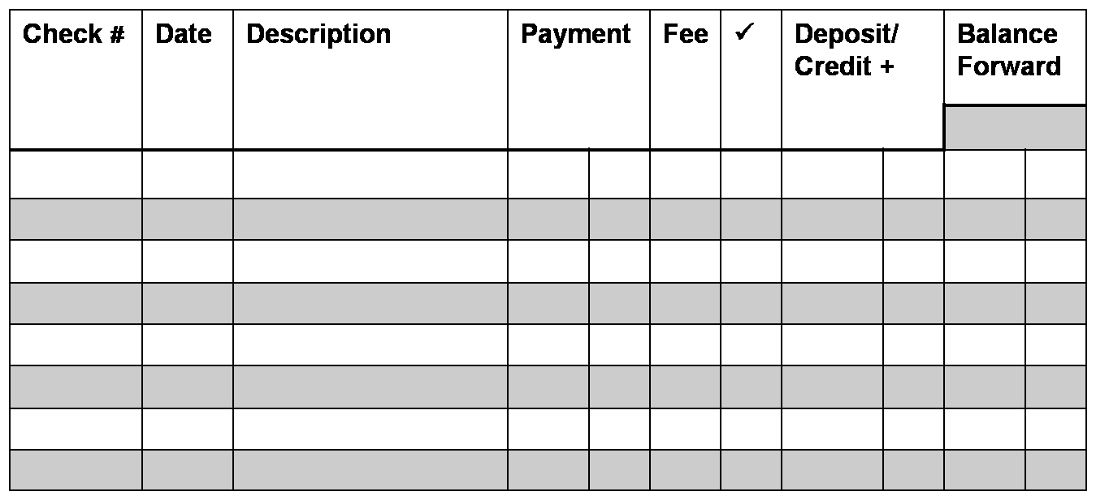Work Together Assignment

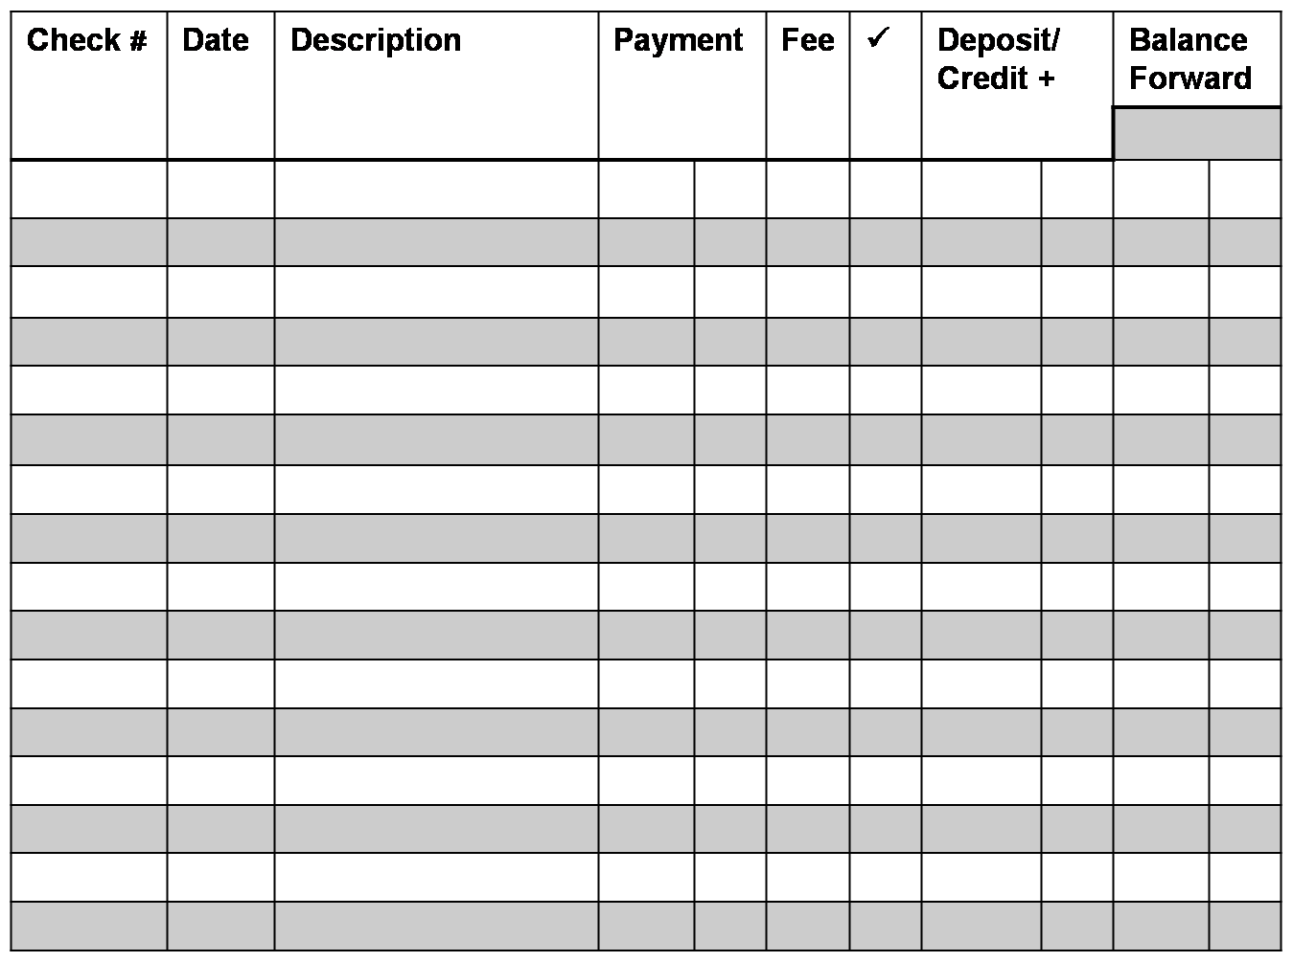

Bank Reconciliation

Work Together Assignment

Bank Reconciliation

1. Write ending balance as shown on bank statement:
2. Add credits or deposits made that do not appear on statement:
3. Subtotal: add Lines 1 and 2:
4. Write total checks outstanding payments not processed.

|  |  |  |
| --- | --- | --- |
| Checks/WD | Amount | |
|  |  |  |
|  |  |  |
|  |  |  |
|  |  |  |
|  |  |  |

1. Subtract line 4 from line 3 and write balance

(checkbook balance and line 5 should equal or an error in your records).